**DLD LAB 10 – In lab and Home Tasks**

**Task 01:**

**Part A:**

A3 = 8 + 9 = 0 + 1 = 1

A2 = 4 + 5 + 6 + 7 = 0 + 0 + 0 + 0 = 0

A1 = 2 + 3 + 6 + 7 = 1 + 0 + 0 + 0 = 1

A0 = 1 + 3 + 5 + 7 + 9 = 0 + 0 + 0 + 0 + 1 = 1

So, we get 1011 as output which is the binary for 11.

**Part B:**

The output, 1011 is not a valid BCD number because it exceeds the binary of 9 i.e. 1001.

**Part C:**

The encoder does not give the correct BCD number as output, since BCD numbers are restricted to 0-9 in binary and it is giving greater number than binary in this case 11.

**Task 02:**

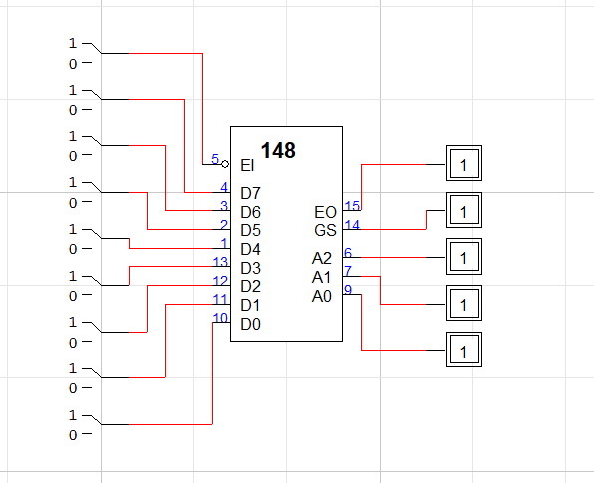

**Truth Table**

|  |  |  |  |  |  |  |  |  |  |  |  |
| --- | --- | --- | --- | --- | --- | --- | --- | --- | --- | --- | --- |
| **0** | **1** | **2** | **3** | **4** | **5** | **6** | **7** | **X** | **Y** | **Z** | **V** |
| 0 | 0 | 0 | 0 | 0 | 0 | 0 | 0 | X | X | X | 0 |
| 1 | 0 | 0 | 0 | 0 | 0 | 0 | 0 | 0 | 0 | 0 | 1 |
| X | 1 | 0 | 0 | 0 | 0 | 0 | 0 | 0 | 0 | 1 | 1 |
| X | X | 1 | 0 | 0 | 0 | 0 | 0 | 0 | 1 | 0 | 1 |
| X | X | X | 1 | 0 | 0 | 0 | 0 | 0 | 1 | 1 | 1 |
| X | X | X | X | 1 | 0 | 0 | 0 | 1 | 0 | 0 | 1 |
| X | X | X | X | X | 1 | 0 | 0 | 1 | 0 | 1 | 1 |
| X | X | X | X | X | X | 1 | 0 | 1 | 1 | 0 | 1 |
| X | X | X | X | X | X | X | 1 | 1 | 1 | 1 | 1 |

**Task 03:**

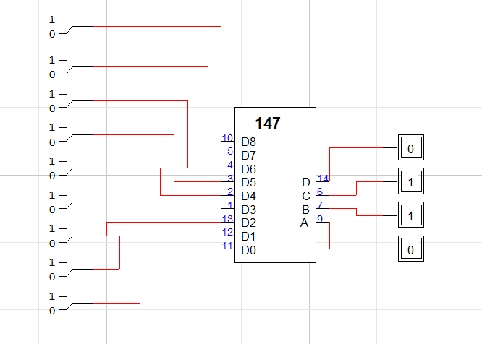

**Truth Table**

|  |  |  |  |  |  |  |  |  |  |  |  |  |
| --- | --- | --- | --- | --- | --- | --- | --- | --- | --- | --- | --- | --- |
| **0** | **1** | **2** | **3** | **4** | **5** | **6** | **7** | **8** | **D** | **C** | **B** | **A** |
| 1 | 1 | 1 | 1 | 1 | 1 | 1 | 1 | 1 | 1 | 1 | 1 | 1 |
| 0 | 1 | 1 | 1 | 1 | 1 | 1 | 1 | 1 | 1 | 1 | 1 | 0 |
| X | 0 | 1 | 1 | 1 | 1 | 1 | 1 | 1 | 1 | 1 | 0 | 1 |
| X | X | 0 | 1 | 1 | 1 | 1 | 1 | 1 | 1 | 1 | 0 | 0 |
| X | X | X | 0 | 1 | 1 | 1 | 1 | 1 | 1 | 0 | 1 | 1 |
| X | X | X | X | 0 | 1 | 1 | 1 | 1 | 1 | 0 | 1 | 0 |
| X | X | X | X | X | 0 | 1 | 1 | 1 | 1 | 0 | 0 | 1 |
| X | X | X | X | X | X | 0 | 1 | 1 | 1 | 0 | 0 | 0 |
| X | X | X | X | X | X | X | 0 | 1 | 0 | 1 | 1 | 1 |
| X | X | X | X | X | X | X | X | 0 | 0 | 1 | 1 | 0 |

**Task 04:**

